DAY-11(19/6/2025)
Emp ID : 110714877
NAME :Kinnera venkatamma

Task1. What are Streams ?
Streaming is filtering, mapping, reducing data when we search data from database it gives desired result with less code
Task2.Write about
1.Boilerplate code:
2.Lack of parallelism
3. Lack of Composition

Boilerplate code:
Refers to a section of code that is repeated in multiple places with little or no variation. It’s often used to describe code that is necessary for a particular task or functionality but doesn’t add much value to the overall logic of the program
Lack of parallelism:
When discussing boilerplate code, "lack of parallelism" refers to inablility of a program or algorithm to take advantage of multiple processors or cores to execute tasks simultaneously. This can lead to slower performance, especially in large applications.
Lack of composition:
"Lack of composition" refers to the inability to easily combine boilerplate code with other functions or operations in a modular and reusable way. This can make the code harder to maintain and extend.
Task3. List of Intermediate and terminal operations

Intermediate operations :filter(), map(), flatMap() , sorted(),distinct()
Terminal operations : forEach() , collect(),reduce(), findFirst(), findAny()
Task4.

import java.lang.FunctionalInterface;

// this is functional interface
@FunctionalInterface
interface MyInterface{

// abstract method
double getPiValue();
}

public class Main {

public static void main( String[] args ) {

// declare a reference to MyInterface
MyInterface ref;

// lambda expression
ref = () -> 3.1415;

System.out.println("Value of Pi = " + ref.getPiValue());
}
}

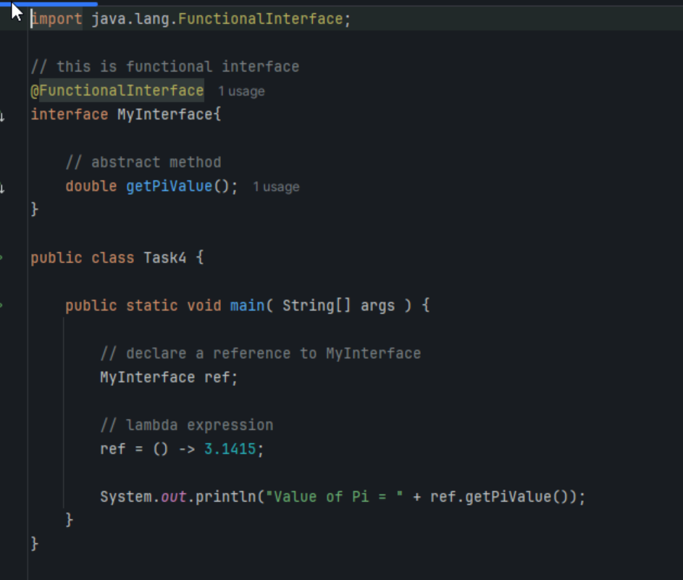

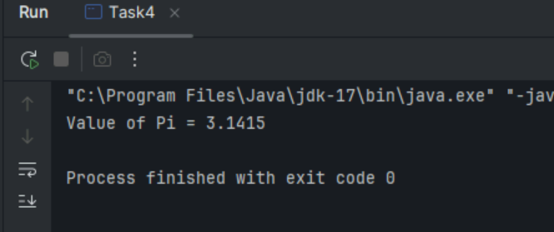
Task 5:

@FunctionalInterface
interface MyInterface {

// abstract method
String reverse(String n);
}

public class Main {

public static void main( String[] args ) {

// declare a reference to MyInterface
// assign a lambda expression to the reference
MyInterface ref = (str) -> {

String result = "";
for (int i = str.length()-1; i >= 0 ; i--)
result += str.charAt(i);
return result;
};

// call the method of the interface
System.out.println("Lambda reversed = " + ref.reverse("Lambda"));
}

}

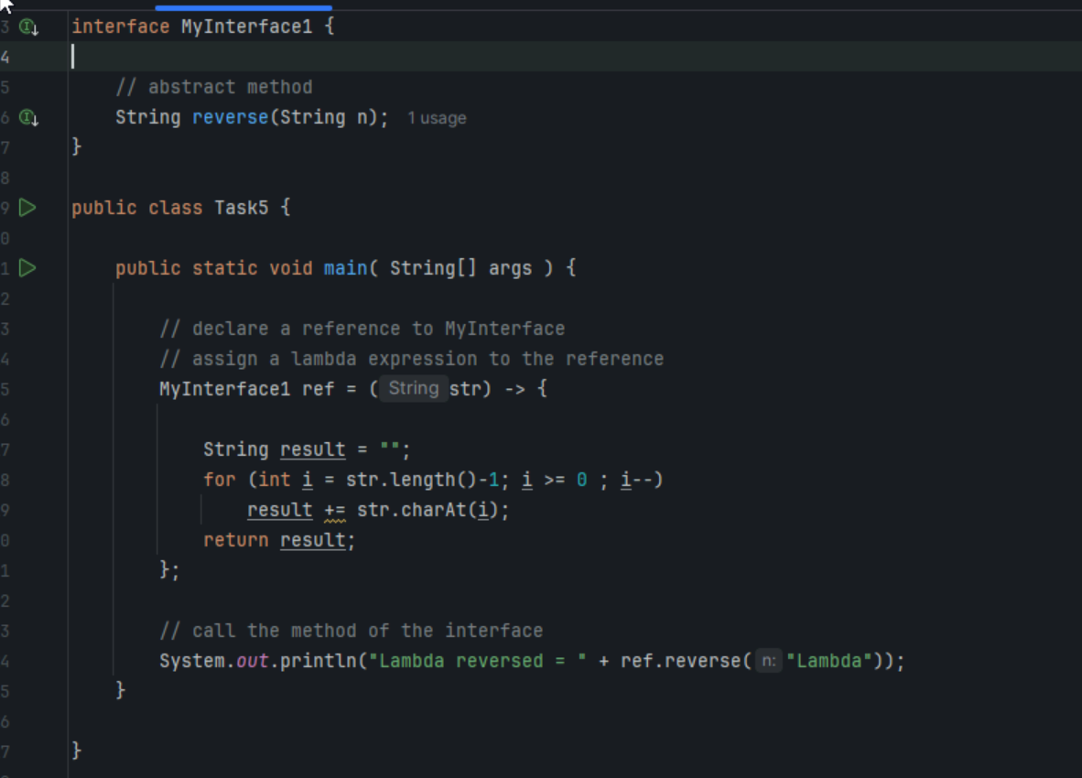
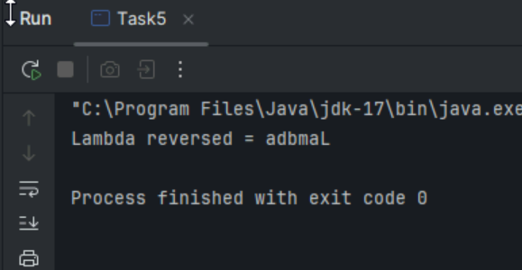
Task 6:

import java.util.ArrayList;
import java.util.List;

public class StreamMain {

// create an object of list using ArrayList
static List<String> places = new ArrayList<>();

// preparing our data
public static List getPlaces(){

// add places and country to the list
places.add("Nepal, Kathmandu");
places.add("Nepal, Pokhara");
places.add("India, Delhi");
places.add("USA, New York");
places.add("Africa, Nigeria");

return places;
}

public static void main( String[] args ) {

List<String> myPlaces = getPlaces();
System.out.println("Places from Nepal:");

// Filter places from Nepal
myPlaces.stream()
.filter((p) -> p.startsWith("Nepal"))
.map((p) -> p.toUpperCase())
.sorted()
.forEach((p) -> System.out.println(p));
}

}

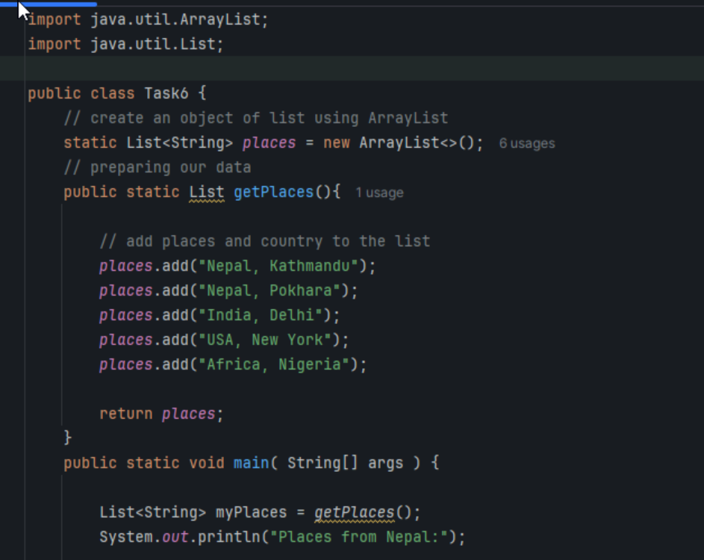
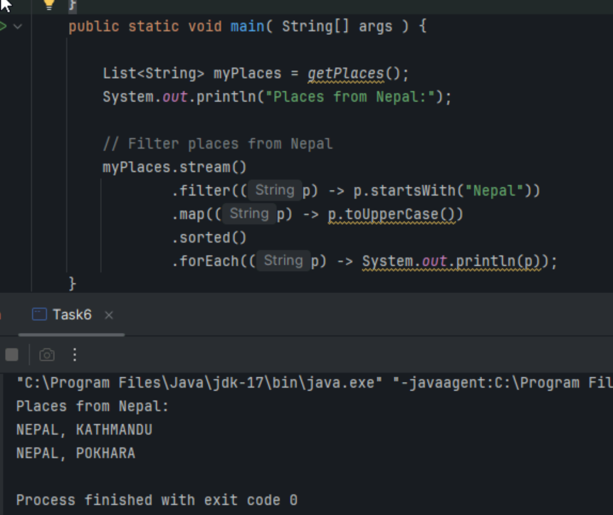
Task 7:

Write a code to create a array list to store 5 integers and display the square of each no..

Hint:

List<Integer> squareofNums = numbers.stream()
.map(num->num*num)
.collect(Collectors.toList());

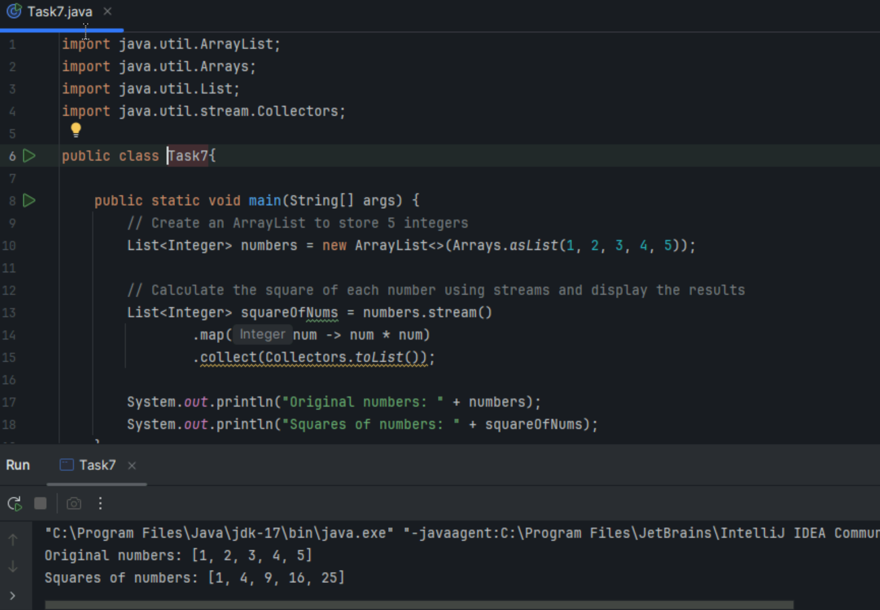

Task 8:

What do you understand by map()?

map() is a higher-order function that applies a given function to each element of a collection (like an array or list) and returns a new collection containing the results.

Task 9:

Write a code to create an array list and filter the values which are odd numbers and display them..

Hint:
List<Integer> addNumbers = numbers.stream()
.filter(num -> num % 2 !=0)
.collect(Collectors.toList());

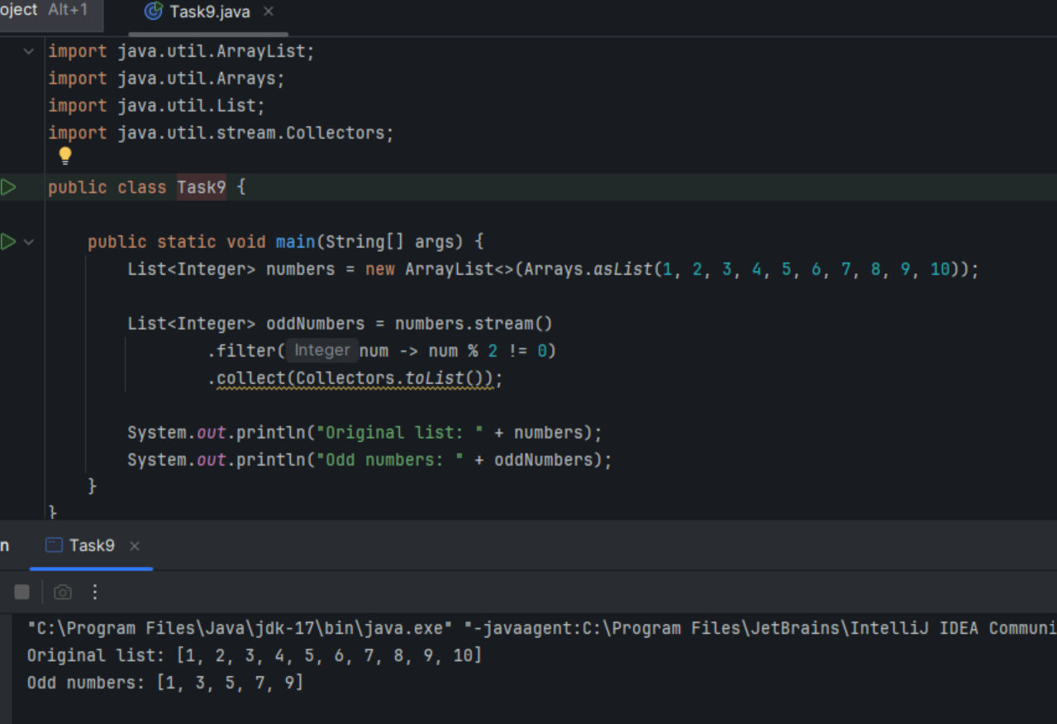

Task 10: What do you understand by filter()?

It’s an Intermediate operation allows to filter elements in a stream based on prediction.
It takes lambda Expression or a method ref as an argument &returns a new stream containing only the element that match the condition
Task 11:
Wap to create an array list to remove duplicate values from the List.

Hint:
List<Integer> RemovDups= numbers.stream()
.distinct()
.collect(Collectors.toList());

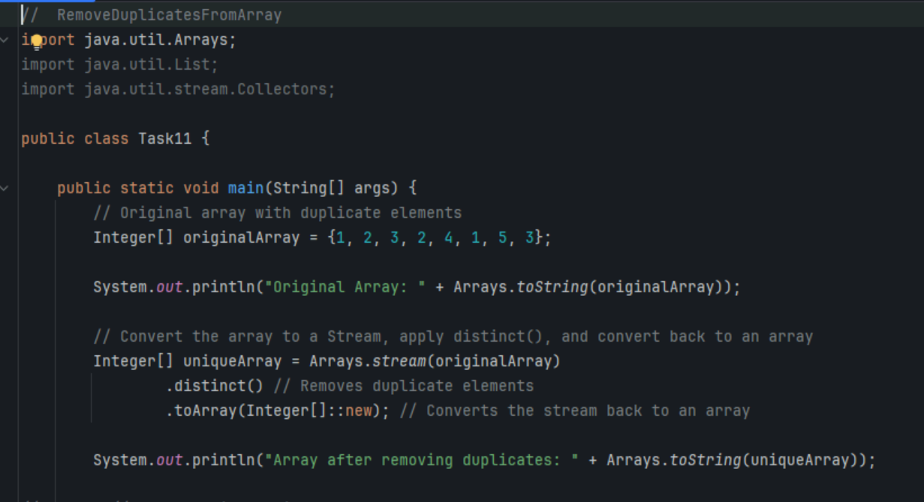
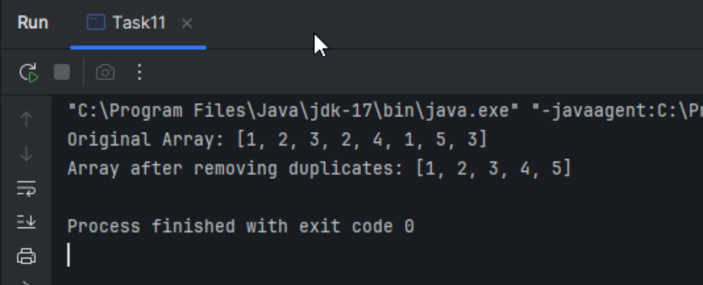

Task12:

What do you understand by distinct()?

Intermediate operations :

distinct() method in java stream is an intermediate operation
It removes duplicate elements from the stream
Sort() -It sorts elements in a stream according to a comparator provided or natural ordering
Limit()- It returns a stream consisting of the elements of the original stream ,truncated to be no longer than a specified maximum size
Skip() - It returns a stream consisting elements of the original stream, skipping the first specified number of elements

Terminal operations:

Foreach -forEach() method applies the specified action to each element in the stream
Collect -This accumulates elements from the stream into a collection or other data structure
reduce() -It combines elements into a single result

Task 13:

Wao to create an arrayList of your friends using string and try to sort them and display

Hint:
List<String> SortedNames= Names.stream()
.sorted()
.collect(Collectors.toList());

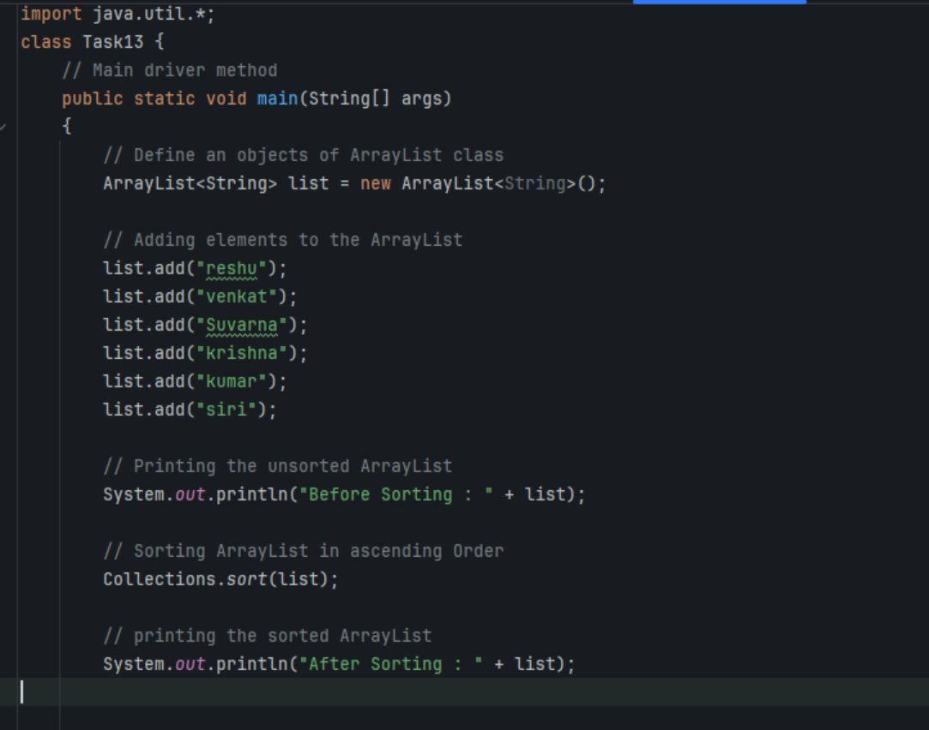
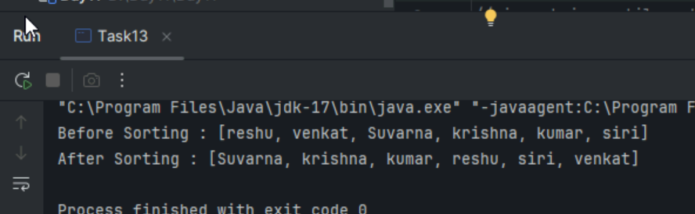

Task 14:

Wap to run a loop / iterate() and limit it to 20 values (1 to 2)
While displaying use for each to limit till 10 numbers.

Hint:
Stream<Integers> nums = Stream
.iterate(1, n -> n+1)
.limit(20);
Nums
.limit(10)
.foreach(System.out::println);

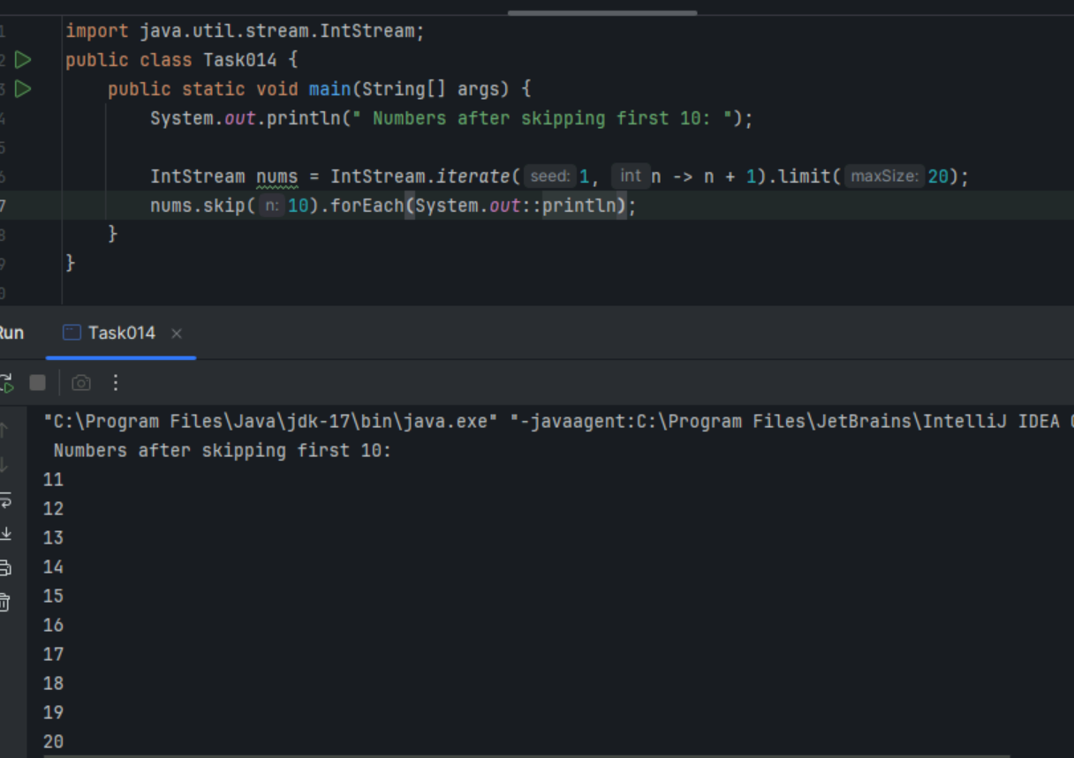

Task 15: (similar to Task 14)

Wap to create an array List skip 15 numbers and print the output using foreach loop

HInt:

Stream<Integers> nums = Stream
.iterate(1, n -> n+1)
.limit(20);

Stream<Integer> SkipNums = nums.skip(15);

Nums.foreach(System.out::println);

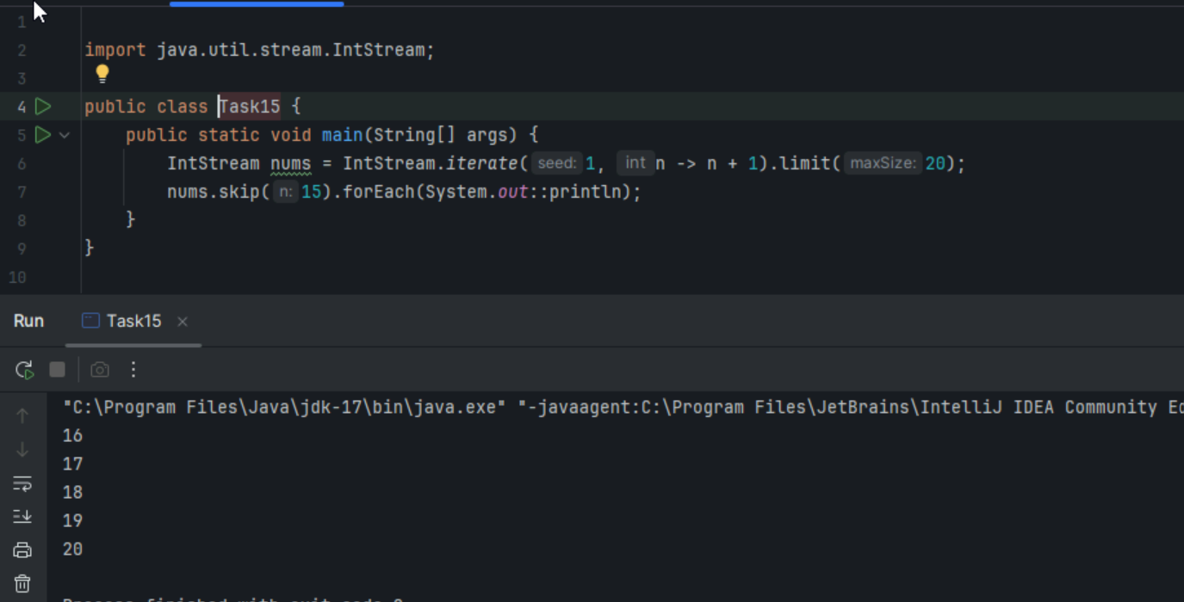

Task 16:

Explain limit and skip methods..

limit() and skip() methods are intermediate operations that allow for manipulation of the elements within a stream. Both methods return a new stream, leaving the original stream unchanged.
Task17. import java.util.Arrays;
import java.util.List;
import java.util.Optional;

public class ReduceExample {
public static void main(String[] args) {

List<Integer> numbers = Arrays.asList(1, 2, 3, 4, 5);

Optional<Integer> sum = numbers.stream().reduce((x, y) -> x + y);
System.out.println("Sum of all elements: " + sum.orElse(0));

Optional<Integer> max = numbers.stream().reduce(Integer::max);
System.out.println("Maximum element: " + max.orElse(0));

List<String> strings = Arrays.asList("Hello", " ", "world", "!");
Optional<String> concatenatedString = strings.stream().reduce((x, y) -> x + y);
System.out.println("Concatenated string: " + concatenatedString.orElse(""));
}
}

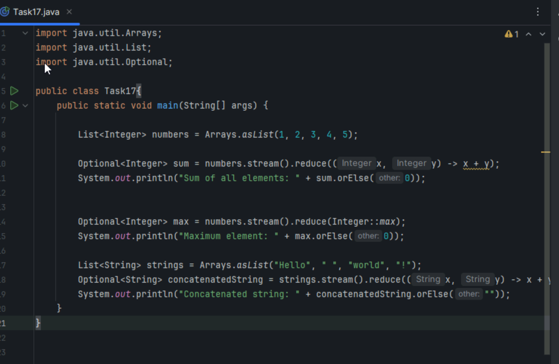
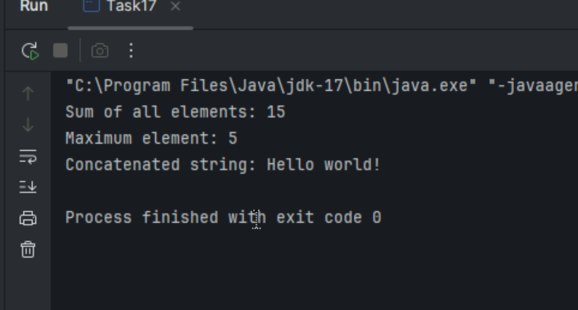
Task 18:

What are the debugging tools in Java.. list down a few..

1.Eclipse
2.IntelliJ IDEA
3. NetBeans
4.VS codes
5.Java Debugger(jbd)

Task 19:Error Messages in Java

compile errors:
1.syntax errors
2.undeclared variable
3.type mismatch
4.missing return statement
5.incompatible method signature
6.class not found

run time errors:
1.Divide by zero
2.NullpointerException
3.ArrayIndexOutofBoundsException
4.NumberformatException
5.FileNotFounfException/IO Exception

Task 20:

Stack trace.. What will it do?

Identify the error
Locate the code
Analyze the code
Solution also

